
Student Enrollment & Course Management System (SECMS)
Shanmuga Industries And Science College
Project Documentation

TEAM MEMBERS
VIGNESH P – Team leader
NIDHSHA R
VIDHYA SRI S
TAMILARASU M
SACHIN G
NAN MUDHALVAN DEPARTMENT - STAFF
P VIGNESHVARAN – HOD
SATHESH – TUTIOR

1. Introduction – VIGNESH P ( TEAM LEADER)
1.1 Project Overview
The Student Enrollment & Course Management System (SECMS) is a Salesforce-based application developed to automate and centralize academic enrollment activities in an educational institution. The system manages student records, courses, instructors, enrollments, approvals, payments, reports, and dashboards within a single platform.
1.2 Purpose of the Project
The purpose of SECMS is to replace manual and fragmented enrollment processes with an automated, scalable, and secure Salesforce solution that ensures:
- Accurate student data management
- Structured enrollment workflows
- Automated validation and approval processes
- Real-time reporting and monitoring

2. System Objectives
- Centralize all academic data in Salesforce
- Reduce manual effort and human errors
- Improve transparency in enrollment and revenue tracking
- Provide role-based access and security
- Enable data-driven decision making using reports and dashboards
3. Technology Stack – (VIGNESH P)
Layer | Technology Used
User Interface | Salesforce Lightning Experience
Business Logic | Salesforce Flows
Database | Salesforce Custom Objects
Automation | Validation Rules, Approval Processes
Reporting | Salesforce Reports & Dashboards
Security | Profiles, Permission Sets, OWD

4. System Architecture Overview
The SECMS architecture consists of Salesforce custom objects (Student, Course, Instructor, Enrollment) integrated with automation tools such as Flows and Approval Processes. Reports and Dashboards consume processed data for real-time monitoring, while security is enforced using profiles and permission sets.
TAMILARASU M
4.1 Architectural Layers – TAMILARASU M
1. Presentation Layer (User Interface)
This layer represents the user-facing components of the system and is built using Salesforce Lightning Experience. It provides an intuitive and responsive interface for all users, including Administrators, Enrollment Officers, and Instructors.
- Lightning Apps and Tabs for navigation
- Record pages for Student, Course, Instructor, and Enrollment objects
- Dashboards and Reports for real-time insights
VIDHYASRI S
2. Application Layer (Business Logic & Automation) – VIDHYASRI S
The application layer handles all business rules and automation logic using Salesforce declarative tools. This layer ensures that enrollment workflows are executed accurately and consistently.
- Salesforce Flows for automation (record-triggered flows)
- Validation Rules for enforcing data integrity
- Approval Processes for enrollment authorization
- Record Types and Page Layouts for process differentiation
3. Data Layer (Database) – VIDHYASRI S
The data layer consists of Salesforce custom objects that store and manage academic information securely.
- Student object stores personal and academic status details
- Course object manages course offerings and fees
- Instructor object maintains faculty information
- Enrollment object acts as a junction object linking students, courses, and instructors
Relationships between objects are established using Lookup relationships to ensure referential integrity and structured data access.
4. Security Layer
Security is enforced across all layers using Salesforce’s built-in security framework.
- Profiles define baseline access for Admin, Enrollment Officer, and Instructor roles
- Permission Sets provide additional, flexible access control
- Organization-Wide Defaults (OWD) control record-level visibility
- Field-Level Security ensures sensitive data is protected
5. Reporting & Analytics Layer
This layer transforms raw data into meaningful insights for decision-making.
- Standard and custom Reports for enrollment, revenue, and approvals
- Interactive Dashboards for visual monitoring of KPIs
- Real-time data updates reflecting system activities
SACHIN G
4.2 System Workflow Overview – (SACHIN G)
- Users access the system through the Salesforce Lightning interface.
- Student, Course, and Enrollment data is entered through structured record pages.
- Validation Rules verify data accuracy before record submission.
- Record-Triggered Flows automate enrollment date population, instructor assignment, and task creation.
- Enrollment requests are routed through Approval Processes.
- Approved enrollments trigger notifications and status updates.
- Reports and Dashboards consume processed data for monitoring and analysis.

4.3 Architecture Benefits – (SACHIN G )
- Scalability: Easily supports increasing students, courses, and users
- Reliability: Salesforce cloud ensures consistent availability
- Security: Strong role-based access and data protection
- Maintainability: Declarative configuration reduces maintenance effort
- Flexibility: Easy integration with future modules such as payment gateways and portals
VIGNESH P
5. Data Model and Records – (VIGNESH P )
5.1 Student Object
Field Name | Data Type | Description
Student Name | Text | Name of the student
Email | Email | Institutional email ID
Phone | Phone | Contact number
Date of Birth | Date | Student DOB
Student Status | Picklist | Active / Inactive
Address | Text Area | Residential address
Sample Student Record
Student Name | Email | Status
VIGNESH | ppvignesh516@gmail.com | Active

5.2 Course Object – (VIGNESH P)
Field Name | Data Type | Description
Course Name | Text | Name of the course
Category | Picklist | Technical / Language / Non-Technical
Duration | Number | Course duration
Course Fee | Currency | Fee amount
Description | Text Area | Course details
Sample Course Record
Course Name | Category
DATA SCIENCE | ADCEMIC YEAR
5.3 Instructor Object
Field Name | Data Type | Description
Instructor Name | Text | Name of instructor
Instructor Code | Text | Unique code
Expertise | Picklist | Subject expertise
Phone | Phone | Contact number
Email | Email | Email ID

Sample Instructor Record
Instructor Name | Expertise
vignesh | Requested

5.4 Enrollment Object
Field Name | Data Type | Description
Student | Lookup (Student) | Enrolled student
Course | Lookup (Course) | Selected course
Instructor | Lookup (Instructor) | Assigned instructor
Enrollment Date | Date | Date of enrollment
Enrollment Status | Picklist | Requested / Approved / Rejected
Fees Paid | Checkbox | Payment status
Total Amount | Currency | Fee amount
Sample Enrollment Record
Student | Course | Status | Fees Paid
Vignesh | Data science | active | Yes

6. Functional Modules Implemented
6.1 Student Management – (VIGNESH P)
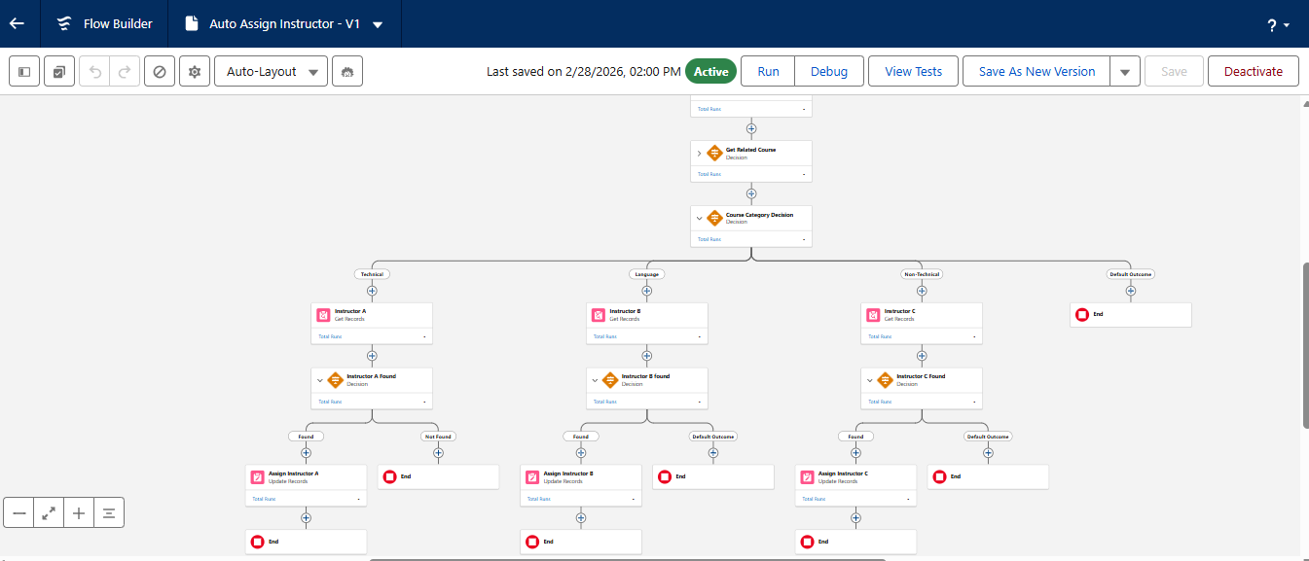
- Create and manage student records
- Email validation using validation rules

NIDHISHA R
6.2 Course Management – (NIDHISHA R )
- Course creation with category and fees
- Course availability for enrollments
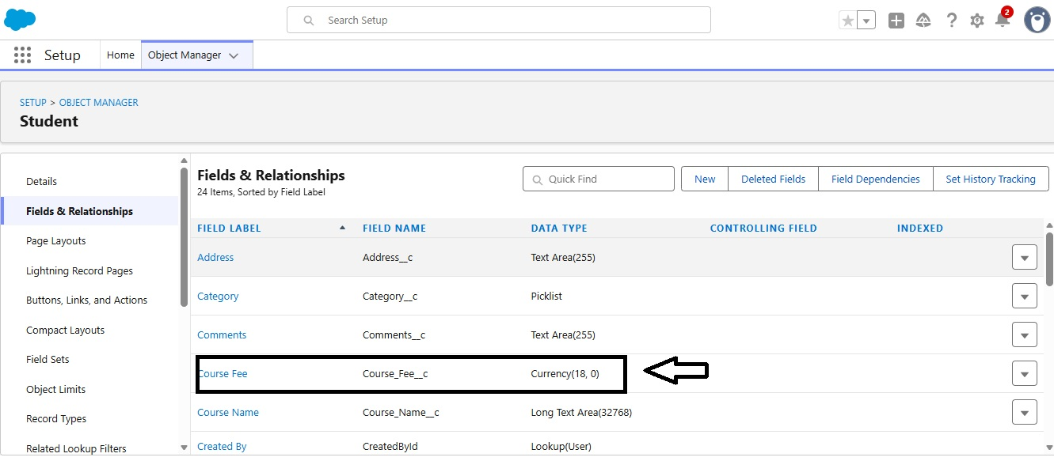

6.3 Enrollment Processing – (NIDHISHA R)
- New Enrollment and Re-Enrollment record types
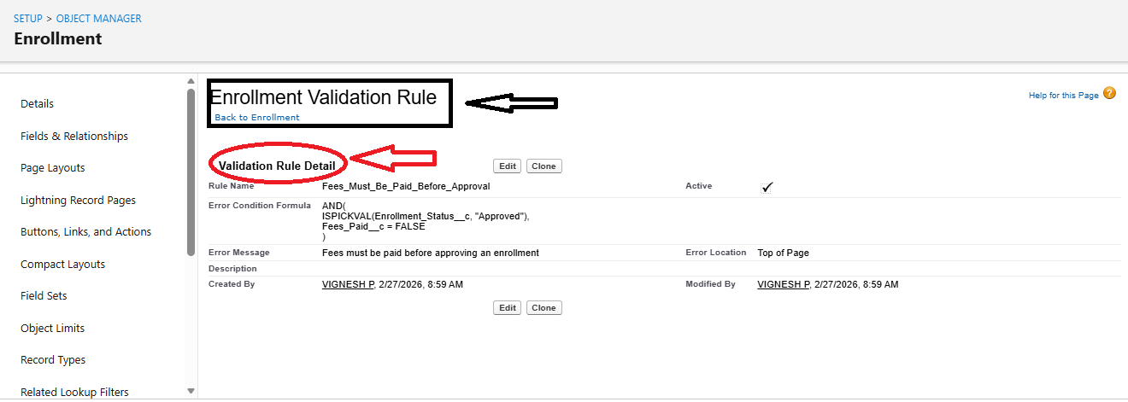
- Validation for fee payment before approval

VIDHYASRI S
6.4 Automation (Flows) – (VIDHYASRI S)
- Auto-populate enrollment date
- Auto-assign instructors based on course category
- Auto-create follow-up tasks
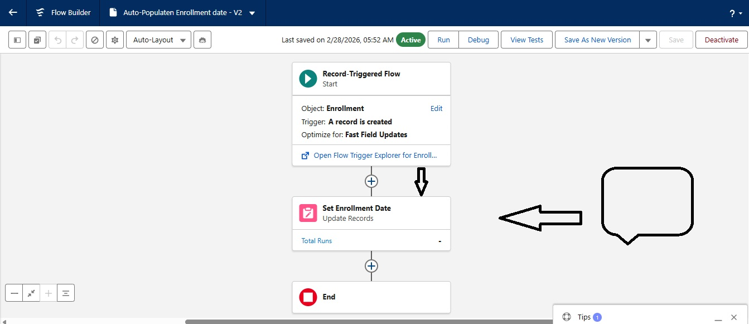
- Email notification on approval

FLOWS

SACHIN G
6.5 Approval Process – (SACHIN G)
- Enrollment requests routed to Admin/Manager
- Auto update status on approval or rejection
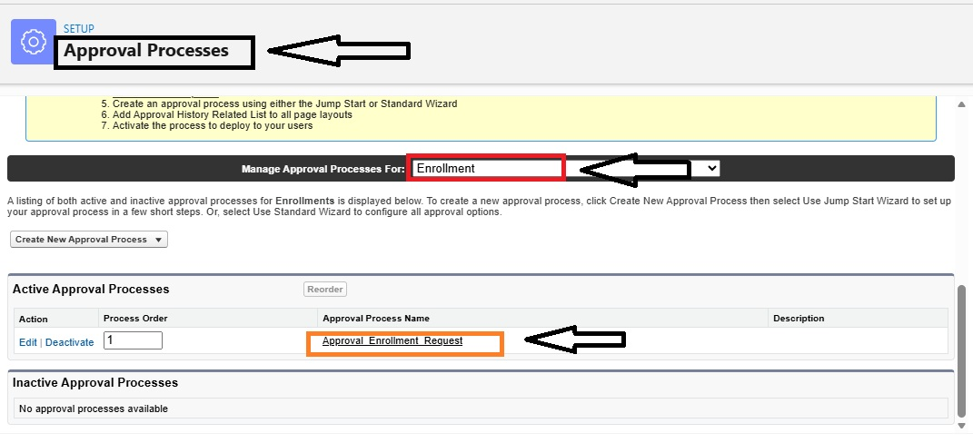
7. Reports and Dashboards – (SACHIN G)
Reports Created
Report Name | Purpose
Students by Status | Track active/inactive students
Enrollments by Course | Monitor course demand
Pending Enrollment Approvals | Track approvals
Revenue Report | Track fees collected

Dashboard – (SACHIN G)
Student Management Dashboard includes:
- Donut chart for student status
- Bar chart for enrollments by course
- Gauge for revenue
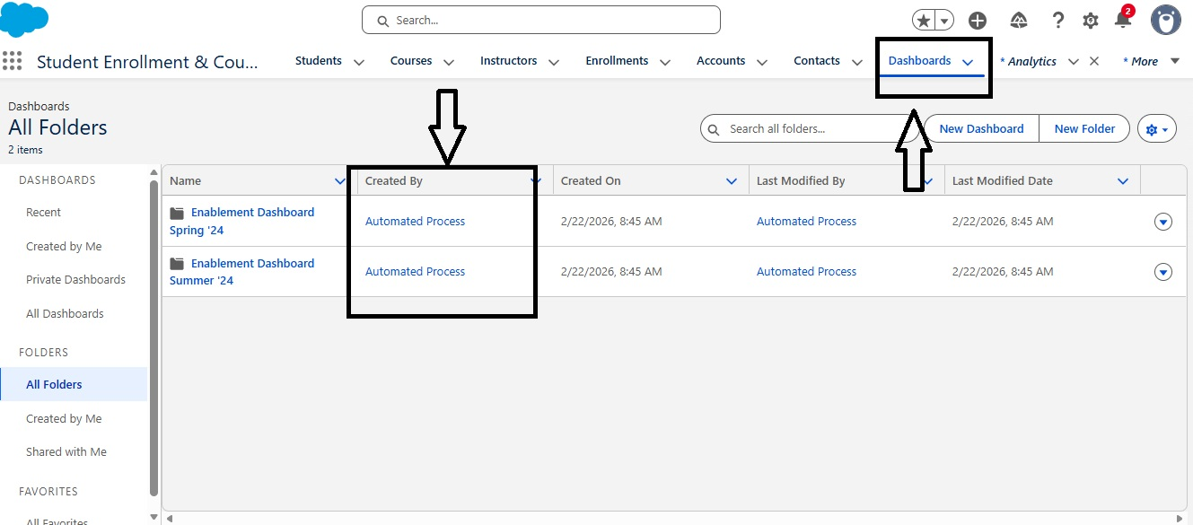
- Table for pending approvals

\

TAMILARASU M
8. Security Configuration – (TAMILARASU M)
Role | Access Level
Admin | Full Access
Enrollment Officer | Create/Edit Enrollments
Instructor | Read-only assigned enrollments

Security features implemented:
- Profiles and Permission Sets
- Organization Wide Defaults (OWD)
- Role-based access control

9. Testing Summary – (TAMILARASU M)
Comprehensive functional and performance testing was carried out to validate that the Student Enrollment & Course Management System (SECMS) meets all specified functional and non-functional requirements. Testing activities were conducted in the Salesforce Developer Environment to ensure system stability, accuracy, and reliability before final submission.
9.1 Functional Testing
Functional testing focused on verifying that each module of the system operates according to the defined requirements.
Student Management Testing
- Verified creation, editing, and deletion of Student records
- Validated mandatory field checks (Name, Email, Status)
- Tested institutional email domain validation rule
Course Management Testing
- Confirmed successful creation and update of Course records
- Verified correct display of course category, duration, and fee
- Ensured courses are selectable during enrollment
Enrollment Processing Testing
- Tested New Enrollment and Re-Enrollment record types
- Verified lookup relationships between Student, Course, Instructor, and Enrollment
- Ensured Enrollment Status updates correctly (Requested, Approved, Rejected)
VIDHYASRI S
Validation Rule Testing – (VIDHYASRI S)
- Confirmed error messages appear when fees are not paid before approval
- Verified prevention of invalid email formats
Approval Process Testing – (VIDHYASRI S)
- Tested submission of enrollment requests for approval
- Verified routing to the correct approver
- Confirmed automatic status updates on approval and rejection
- Tested rejection email notifications
Automation (Flow) Testing – (VIDHYASRI S)
- Verified auto-population of Enrollment Date on record creation
- Tested automatic instructor assignment based on course category
- Verified automatic task creation for pending enrollments
- Confirmed email notifications on enrollment approval
VIGNESH P
9.2 Performance Testing – (VIGNESH P)
Performance testing ensured the system performs efficiently under normal and peak usage conditions.
- Verified quick record creation and update response times
- Tested bulk record insertion without system errors
- Ensured dashboards load without noticeable delay
- Verified reports generate accurate results within acceptable time

9.3 Security Testing
Security testing validated that data access is restricted based on user roles.
- Verified Admin profile has full access
- Confirmed Enrollment Officers can create and update enrollments only
- Verified Instructors can view only assigned enrollments
- Tested Organization-Wide Defaults (OWD) behavior
SACHIN G
9.4 Reporting and Dashboard Validation – (SACHIN G)
- Verified accuracy of data displayed in reports
- Tested grouping and filtering logic in reports
- Confirmed dashboards reflect real-time data updates

9.5 Test Evidence – (SACHIN G)
Screenshots were captured for all major testing activities, including record creation, validation errors, approval actions, automated flow executions, reports, and dashboards. These screenshots serve as documented proof of successful system testing and functionality verification.
Functional and performance testing was conducted to validate:
- Record creation and updates
- Validation rules enforcement
- Approval workflows
- Automation flows execution
- Accuracy of reports and dashboards

Screenshots were captured as evidence during testing.
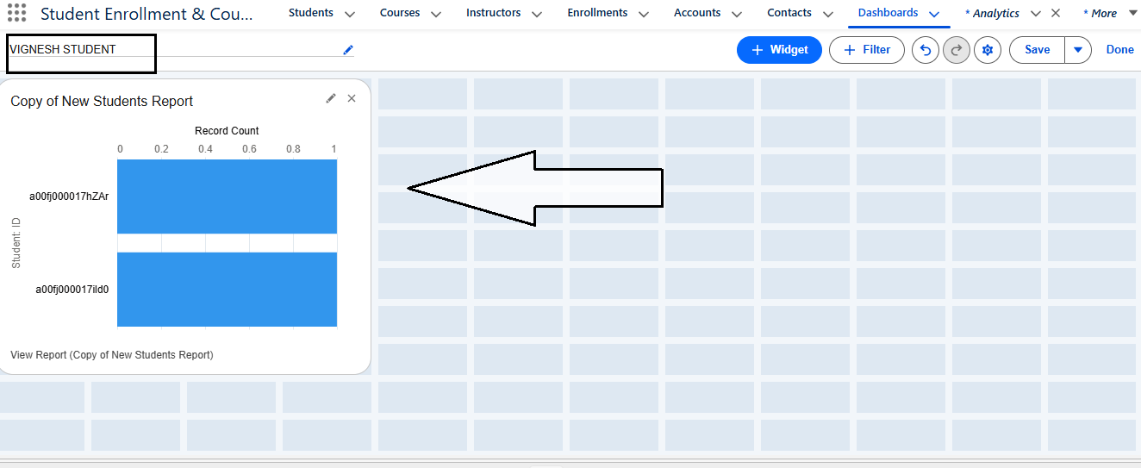
NIDHISHA R
10. Advantages and Disadvantages - (NIDHISHA R)
Advantages
- Centralized data management
- Reduced manual work
- Real-time insights
- Scalable architecture
Disadvantages
- Dependency on Salesforce platform
- Initial setup and configuration effort

Result output:

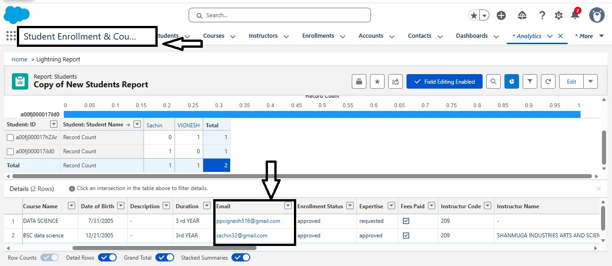

TAMILARASU M
11. Conclusion – (TAMILARASU M)
The Student Enrollment & Course Management System (SECMS) has been successfully designed, developed, and implemented using the Salesforce platform to address the challenges of manual, fragmented, and error-prone academic enrollment processes. This project delivers a complete end-to-end solution that manages the entire student lifecycle—from student registration and course creation to enrollment processing, instructor assignment, approvals, fee tracking, and performance reporting.
By leveraging Salesforce core features such as Custom Objects, Validation Rules, Record Types, Approval Processes, and Flows, the system ensures data accuracy, consistency, and automation across all academic operations. Manual intervention has been significantly reduced, which minimizes errors, avoids duplicate enrollments, and accelerates decision-making processes. Automated validations and approvals ensure that institutional policies—such as fee payment before approval—are strictly enforced.
The implementation of role-based security using Profiles, Permission Sets, and Organization-Wide Defaults (OWD) ensures that sensitive student and academic data is securely accessed only by authorized users. Administrators have complete visibility and control, enrollment officers can efficiently manage registrations, and instructors can view only their assigned enrollments, maintaining confidentiality and data integrity.
The system’s Reports and Dashboards provide real-time insights into key performance indicators such as student status distribution, course-wise enrollment trends, pending approvals, and revenue generated through fees. These analytics empower management to make informed, data-driven decisions and proactively respond to enrollment patterns and operational bottlenecks.
Overall, SECMS demonstrates how Salesforce can be effectively used as a powerful academic management platform. The project not only fulfills all functional and non-functional requirements but also offers scalability, reliability, and flexibility for future enhancements. It serves as a strong foundation for digital transformation in educational institutions and highlights best practices in cloud-based application development, automation, and analytics.
12. Future Scope
- Payment gateway integration
- Student self-service portal
- Mobile application support
- Advanced analytics and AI insights

13. Appendix
- Salesforce Configuration Details
- Custom Objects and Fields
- Reports and Dashboards
Project analysis link :
https://orgfarm-1d8fcddb6a-dev-ed.develop.my.salesforce.com/analytics/wave/report?assetId=00Ofj000008Z0VBEA0&orgId=00Dfj00000L7gsr&loginHost=usa1044.sfdc-8tgtt5.salesforce.com&urlType=sharing&analyticsContext=analyticsTab

